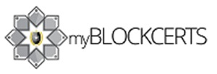

We are glad to inform you have been invited by to UniSZA's new and advanced decentralized blockchain certificate application.You are required to join our application, it will directly take you to our platform where you can change your password to create account. Your certificate will be made avaiable in the platform after your convocation ceremony has been completed. You will receive an email from us to your official putra@unisza. Here is steps to claim your certificate:

- Change the password by clicking the provided link.
- Login to platform after password change.
- Navigate to Blockchain info.
- Download Private Key. Keep your private key saved somewhere very safe. It's important to keep have your private key for any activities on the platform and to claim your certificate.
- Once your convocation ceremony is over, Login again and Navigate to Certificate menu.
- Click on Claim icon, it will prompt you to enter the private key.
- Open the private key you have saved, copy the private hash key, paste and click confirm.
- You have successfully claimed your certificate on myBlockcerts.

